1

**Gayados’ Rental Place’s Payment Management System**

A Feasibility Presented to the Faculty of the CITCS

University of the Cordilleras

In Partial Fulfillment

of the Requirements for the Degree BS in Information Technology

by **Abenes, Enrico Baleña, Juliene**

**Gayados, Doy Ivan Hidalgo, John Kenneth**

Date

August 06, 2024

# ACKNOWLEDGMENT

We would like to express our gratitude to our instructor for their guidance and support throughout the development of this Project Proposal Protocol (PPP) for the Payment Management System (PMS) project. Their expertise and feedback have been invaluable in shaping our understanding of the subject matter.

Special thanks to the management and staff of Gayados' Rental Place for their cooperation and assistance during the research phase. Their insights provided crucial data for our proposal.

We also extend our appreciation to the authors and publishers of the references consulted, which have enriched our understanding of transactional processing systems and business management.

Lastly, we thank our families and friends for their encouragement and support during this project.

|  |  |  |  |
| --- | --- | --- | --- |
| **TABLE OF CONTENTS** |  | | |
| TITLE PAGE |  |  | 1 |
| ACKNOWLEDGEMENT |  |  | 2 |
| TABLE OF CONTENTS |  |  | 3 |
| CHAPTER 1: INTRODUCTION | 4 | - | 5 |
| Background of the study |  |  | 4 |
| Company Profile |  |  | 5 |
| Objective |  |  | 5 |
| Chapter 2: THE EXISTING SYSTEM | 6 | - | 7 |
| Process-Entity-Time Diagram |  |  | 6 |
| Ishikawa Diagram |  |  | 7 |
| Chapter 3: THE PROPOSED SYSTEM | 8 | - | 13 |
| Data Flow Diagram | 9 | - | 10 |
| Context Diagram |  |  | 9 |
| Top Level Diagram |  |  | 9 |
| Explosion of Process Diagram |  |  | 10 |
| Cost Benefit Analysis | 11 | - | 12 |
| Chapter 4: CONCLUSIONS AND RECOMMENDATIONS |  |  | 13 |
| Chapter 5: REFERENCES |  |  | 14 |

**Chapter 1 INTRODUCTION**

**Background of the Study**

This project proposal outlines the development of a Payment Management System for Gayados' Rental Place. The goal is to automate and streamline rental payments, providing a more efficient way for customers to pay and for the business to manage payments and customer information.

The Transactional Process System chosen for this study is a Payment Management System specifically designed for rental businesses. This system will handle transactions related to rental payments, automate the payment process, and maintain accurate records.

A Computer Based Information System integrates hardware, software, and human resources to collect, process, store, and disseminate information. In the context of the Payment Management System, the CBIS will facilitate online payments, track rental statuses, manage customer data, and generate reports, enhancing operational efficiency and accuracy.

**Company Profile**

**Company Name**: Gayados' Rental Place **Location**: 16 Adarna Street, Dizon Subdivision, Baguio City, Philippines **Business Type**: Rental Property Management

**Services**: Provides rental accommodations and manages tenant transactions and records.

**Objectives**

The main objective of the study is to introduce CBIS in Gayados' Rental Place through the Payment Management System specifically achieving the following:

1. To determine the current state of the existing payment management system;
2. To identify problems and concerns encountered in the existing payment management system;
3. To propose features that will address the problems and concerns in the existing payment management system; and
4. To justify the economic feasibility of the proposed payment management system.



**Chapter 2**

References 181

# THE EXISTING SYSTEM

Currently, Gayados' Rental Place relies on a manual payment process where customers pay in cash or via bank transfers, with records maintained in physical ledgers. This system is prone to errors and delays, as it lacks the capability for real-time updates, leading to inefficiencies and potential inaccuracies in record- keeping.

**Process-Entity-Time Diagram**

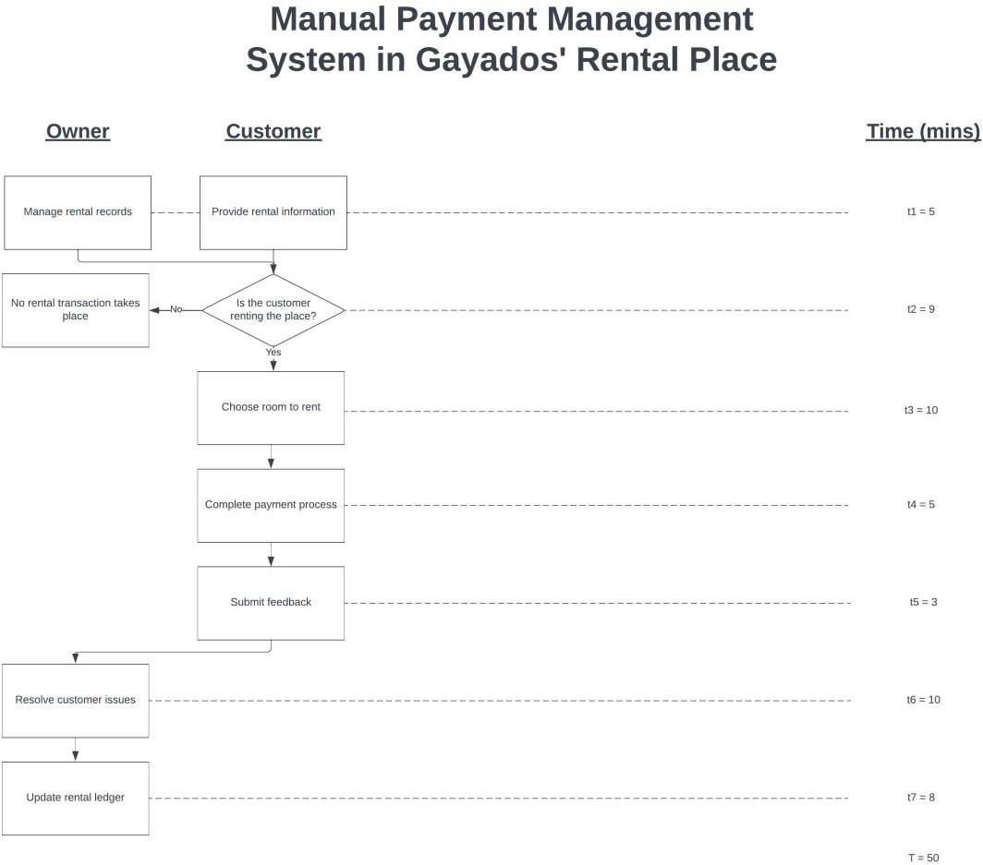

**Ishikawa Diagram**

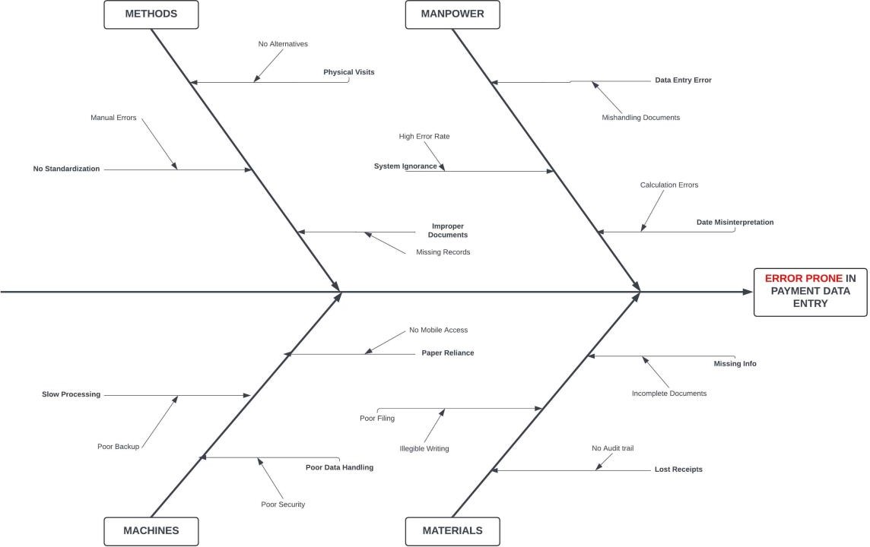

**Chapter 3**

# THE PROPOSED SYSTEM

The proposed Computer-Based Information System (CBIS), a Payment Management System, aims to automate the rental payment process, enhancing efficiency and customer satisfaction. This system will enable customers to make online payments using various methods, including GCash, banks, and PayMaya, ensuring convenience and flexibility. By updating payment records in real-time, the system will reduce errors and provide instant transaction confirmations, maintaining accurate financial records.

Additionally, it will manage comprehensive customer information, allowing for better service and quick resolution of queries.

The system’s capability to generate detailed financial reports is another significant advantage, aiding the management team in making informed decisions. These reports will include summaries of total payments, overdue accounts, and financial projections, facilitating effective financial planning. The automated process will free up staff time, allowing them to focus on other critical tasks, while robust security measures will protect sensitive data. Overall, the Payment Management

System will streamline operations, ensure data accuracy, and enhance decision-making processes, contributing to the overall efficiency and success of the rental business.

**Data Flow Diagram Context Diagram**

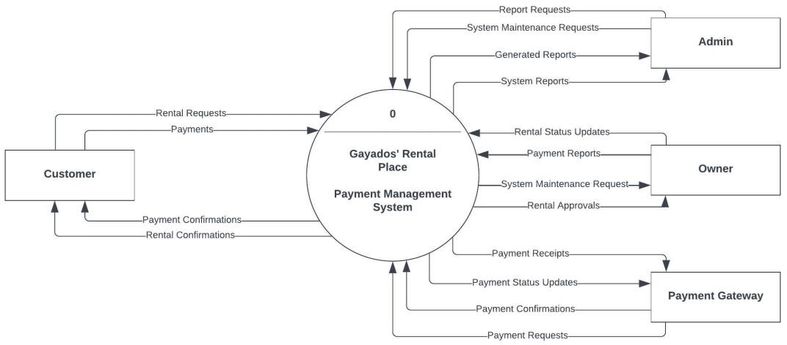

**Top Level Diagram**

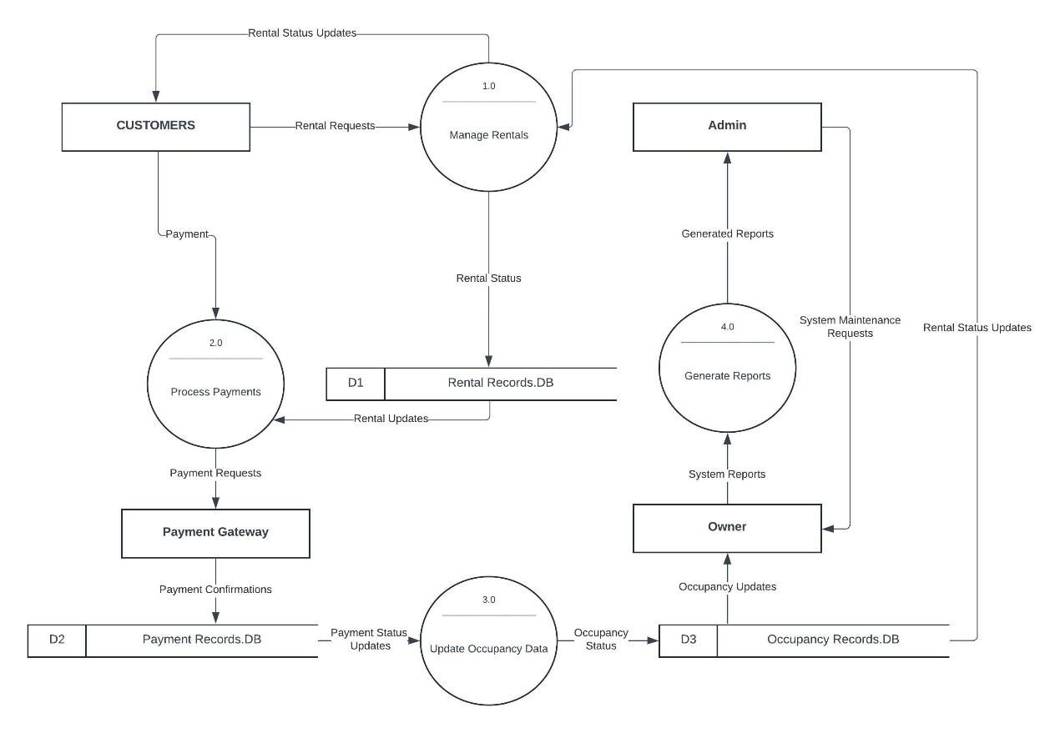

**Explosion of Process 1.0 (Manage Rentals)**

**Explosion of Process 2.0 (Process Payments)**

**Explosion of Process 3.0 (Update Occupancy Data)**

**Explosion of Process 4.0 (Generate Reports)**

**Cost Benefit Analysis**

1. **Development Cost (DC)**

|  |  |  |
| --- | --- | --- |
| New Computer | 1 lot | ₱30,000 |
| Professional Fees | 1 lot | ₱25,000 |
| Training Fees | 1 lot | ₱2,000 |
| **Total** |  | **₱57,000** |

1. **Operating Costs**
   1. **Existing Operating Costs (EOC)**

|  |  |
| --- | --- |
| Inventory Supplies | ₱22,000 |
| Maintenance | ₱22,000 |
| Salaries  Utilities | ₱240,000  ₱37,000 |
| **Total** | **₱321,000** |

* 1. **Proposed Operating Costs (POC)**

|  |  |
| --- | --- |
| Inventory Supplies | ₱15,000 |
| Maintenance | ₱15,000 |
| Salaries  Utilities | ₱240,000  ₱30,000 |
| **Total** | **₱300,000** |

* 1. **Saving (SN)**

SN = ₱EOC – POC

SN = ₱321,000 – 300,000

# SN = ₱21,000



* 1. **Comparative Table**

|  |  |  |  |  |  |
| --- | --- | --- | --- | --- | --- |
| **Year (n)** | **Savings (SN)** | **Interest (1+i)^n** | **Present Value**  **(PV)** | **Cumulative PV (CPV)** | **MARK** |
| 1 | ₱21,000 | 1.20 | ₱17,500 | ₱17,500 | X |
| 2 | ₱21,000 | 1.44 | ₱14,583.33 | ₱32,083.33 | X |
| 3 | ₱21,000 | 1.73 | ₱12,138.73 | ₱44,222.06 | X |
| 4 | ₱21,000 | 2.07 | ₱10,144.93 | ₱54,366.99 | X |
| 5 | ₱21,000 | 2.49 | ₱8,433.73 | ₱62,800.72 | ✓ |

* 1. **Pay Back Period (PBP)**

PBP = ((DC - CPV of the last x mark) / PV of the check mark) + number of x marks

PBP = ((₱57,000 - ₱54,366.99) / ₱8,433.73) + 4 years

PBP = 0.31 + 4 years

**PBP = 4.44 years**

* 1. **Net Present (NPV)**

NPV = CPV of the 5th year – DC NPV = ₱62,800.72 - ₱57,000 **NPV = ₱5,800.72**

* 1. **Return on Investment (ROI)**

ROI = (NPV / DC) x 100%

ROI = (₱5,800.72 / ₱57,000) x 100% ROI = 0.10176 x 100%

# ROI = 10.18%

**CONCLUSIONS AND RECOMMENDATIONS**

**Conclusions**

The current manual payment system at Gayados' Rental Place is inefficient and error-prone, causing delays and inaccuracies. The proposed Payment Management System (PMS) will address these issues by enabling online payments, real-time data updates, and automated reporting. This will enhance efficiency and accuracy for both owners and customers. With a 10.11% ROI over five years, the system is economically viable and beneficial for the business.

**Recommendations**

# REFERENCES

* + 1. **BOOKS**

Laudon, K. C., & Laudon, J. P. (2020). Management information systems: Managing the digital firm (16th ed.). Pearson.

Stair, R. M., & Reynolds, G. W. (2019). Principles of information systems (13th ed.). Cengage Learning.

O'Brien, J. A., & Marakas, G. M. (2010). Management information systems (10th ed.). McGraw-Hill/Irwin.

Turban, E., Volonino, L., & Wood, G. R. (2013). Information technology for management: Advancing sustainable, profitable business growth (9th ed.). Wiley.

# JOURNAL ARTICLES

Coupa. (2023). B2B payment management systems reimagined for the 2020’s. Retrieved from [https://www.coupa.com/blog/b2b](http://www.coupa.com/blog/b2b-payment-management-systems)-payment[-management-systems](http://www.coupa.com/blog/b2b-payment-management-systems)

FreshBooks. (2023). 10 best payment processing companies in 2024. Retrieved from [https://www.freshbooks.com/blog/best](http://www.freshbooks.com/blog/best-payment-processing-)-payment[-processing-](http://www.freshbooks.com/blog/best-payment-processing-) companies

Host Merchant Services. (2023). Front-end and back-end payment processing: A detailed guide. Retrieved from [https://www.hostmerchantservices.com/front](http://www.hostmerchantservices.com/front-end-and-back-)-end-and[-back-](http://www.hostmerchantservices.com/front-end-and-back-) end-payment-processing

WallStreetMojo. (2023). Payment management system - What is it, features, examples. Retrieved from [https://www.wallstreetmojo.com/payment](http://www.wallstreetmojo.com/payment-management-system)-[management](http://www.wallstreetmojo.com/payment-management-system)-system

Ayyagari, M., Beck, T., & Demirguc-Kunt, A. (2007). Small and medium enterprises across the globe. Small Business Economics, 29(4), 415-434. https://doi.org/10.1007/s11187-006-9002-5

Daniel, E., & Storey, C. (1997). On-line banking: Strategic and management challenges. Long Range Planning, 30(6), 890-898. https://doi.org/10.1016/S0024-

6301(97)00074-0